What is OSNI Fusion?
OSNI Fusion is the new largescale vector product and is replacing OSNI Largescale. It consists of a more intuitive structure and contains 12 main themes, with the existing largescale feature types being held as attributes. Each feature will have a unique identifier and life cycle information. The full polygonisation of OSNI Fusion will facilitate the linkage of other products via unique identifiers.
PRODUCT INFORMATION
• Replaces OSNI Largescale
• Intuitive structure with 12 main themes
• Full polygonisation of ground surface consisting of water, transport and land features
• Bespoke area selection will be available through the OSNI Online Map Shop
• Links will be embedded in the data to enable easier joins to other OSNI data, using unique IDs
• Rendering files are available to licensees
• Full attribution has been migrated from existing OSNI Largescale into new OSNI Fusion structure
Key Features:
- Simplified data structure
- 12 main themes
- Full polygonisation
- Unique identifiers
- Feature level attribution
- Feature life cycle information

TECHNICAL SPECIFICATION
Format
- Full coverage in GDB and Extended TAB
- Tiled available as GDB, TAB, DXF and DWG.
- Bespoke area data will be available in a range of formats
Supply – Digital
Availability – Full coverage, bespoke and tiled
Tile Size – 0.4km x 0.6km and 0.8km x 1.2km
Coverage – Full coverage of Northern Ireland
Update Frequency – Data updated continually
Scale - 1:1250 - 1:2500 scale
Co-ordinate Reference System – ESPG 29902 / TM65

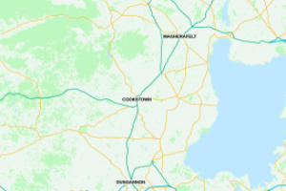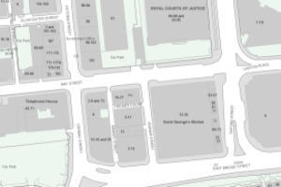
Data Structure
LIS Land Intertidal and Sea – provides context to land area and includes polygon feature to denote the area between the HWWMT and LWMMT

Full polygonisation at ground level consists of:

LP Land parcel - polygon features designated as Built if there is a building in the polygon e.g. a farmhouse or Natural if there is no building in the polygon

TR Transport - polygon feature denoting the widest extent of the road, encompassing footpaths, verges and drivable surface

WA Water - polygon features for standing water and water course (i.e. lakes and rivers)

Real world features:

BU Buildings - polygon features attributed with type e.g. dwelling, education, commercial

GC Ground cover - polygons features classified into Manmade (e.g. car parks), Bare Earth (e.g. mud, shingle, flat rock) and Vegetation (e.g. rough pasture, coniferous etc.)

PE Perimeters - line features such as fence, hedge and bank which may be coincident with the edges of the land parcels
ST Structures - stored as points (e.g. posts at the start of a pedestrian zone), lines (e.g. antiquity features) and polygons (e.g. tanks). Structures will evolve over time
Descriptive Features:

Annotations – A static raster layer set at 1:1250 scale, providing contextual labels to aid user interpretation of the map.

GE Grid extents - grid layouts to reference to other OSNI datasets

TE Text - point features denoting descriptive and distinctive names

SI Sites - polygon features to denote a notional area that does not have a defined extent – e.g. Mourne Mountains. Not yet in the product. Sites will be developed in the future and evolve over time

There is also a legacy feature class that will be reduced over time:

LF Legacy features - miscellaneous features that did not fit the main themes e.g. slope geometry, antiquities. Also currently contains features such as text that have not yet been migrated. This feature class will diminish over time as text is migrated to be an attribute of the features

Product Enquires and Feedback
mapping.helpdesk@finance-ni.gov.uk

