What is Orthophotography?
Orthophotography is high quality georeferenced digital 3 band aerial photography. Orthophotographs are scale-accurate raster images that offer a detailed bird’s-eye view of the landscape. Any distortions caused by the earth’s surface or aircraft movement have been removed by a process of orthorectification to ensure the images are accurate. Photographs are taken in optimal weather conditions to provide the best possible images.

PRODUCT INFORMATION
• Orthophotography capture began in March 2003
• Orthophotographs are available in versions (full coverage of NI) up to 2014; they are supplied by year from 2013 (only coverage for areas flown that year)
• Each pixel represents a real-world distance of 10cm (2022 onwards), 16cm (2012-2021) for digital and 25cm (2003-2012) for film imagery
• Geo-referenced: co-ordinates can be found for any point on the map using GI software and can be used with other OSNI mapping and address data
Key Features:
- Consists of three colour bands: Red, Green and Blue
- Birds-eye view of topography of the land
- Natural and man-made features

TECHNICAL SPECIFICATION
Format – JPG, ECW
Supply – Digital
Availability – Tile
Tile Size – 2.4Km x 1.6Km
Coverage – 3971 tiles covering Northern Ireland
Update Frequency – 3 year cycle
Resolution – 10cm pixel size (2022 onwards), 16cm pixel size (2012-2021)
Maximum file size – 85MB JPG, 173MB ECW
Co-ordinate Reference System – EPSG 29903 / TM75

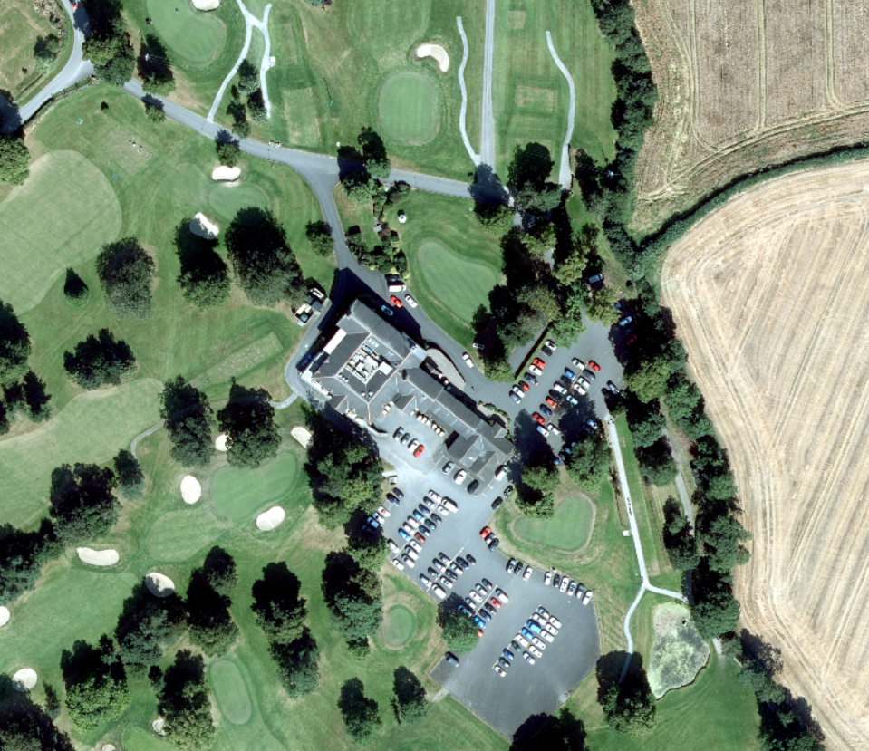

APPLICATIONS
- Ideal background mapping for GIS
- Planning – identify development/change in the land
- Environmental analysis/assessment
- Development and land use planning
- Watershed analysis
- Civil engineering
- Engineering design
- Asset management
- Municipal and government maps
- Right-of-way mapping
- Public and private land development
- Land-use identification

Product Enquires and Feedback
mapping.helpdesk@finance-ni.gov.uk

