What is Pointer?
Pointer is the most comprehensive and authoritative address database for Northern Ireland. It is maintained by LPS with input from other authoritative sources, local district councils and Royal Mail. This is the common standard address dataset with co-ordinates for every property in Northern Ireland.
TECHNICAL SPECIFICATION
Format – CSV
Supply – Digital – Available as full file and updates only
Availability – LGD and Full Northern Ireland
Coverage – LGD or Full Northern Ireland
Update Frequency – Daily
Maximum file size – 378MB
Co-ordinate Reference System – ESPG 29902 / TM65

Key Features:
- UPRN
- Co-ordinate for each record
- Full address information
- Building and Address status
- Building Classification
- Administrative Boundary detail
- Townland names
- Land Parcel Fusion ID
- Building Polygon Fusion ID

PRODUCT INFORMATION
• Supplied as all NI coverage; full product available daily and update-only products available; monthly, quarterly, yearly, weekly and daily
• Individual Local Government District (LGD) datasets are supplied as full product and monthly updates
• As well as address information, Pointer records contain the building and address status and the building classification
• Townland name is added to all addresses
• A Unique Property Reference Number (UPRN) is assigned to each address
• An extension file links each Pointer record to additional administrative boundary information using the UPRN field
• A rejected file includes the rejections of incorrect addresses. Reasons for the rejection of an address includes, but is not limited to, an address no longer valid due to changes to site layout, address entered in error or duplicate address
• Can be linked with OSNI Fusion through land parcel and building IDs, known as their FusionIDs
• Each record can be linked to LPS Property Data using the UPRN field and the Transport Network using the USRN (Unique Street Reference Number)
• Pointer consists of almost 1 million points with ~910,000 as Built; Approved
• Each record contains an Irish Grid co-ordinate
• Approximately 99% match with LPS property Data

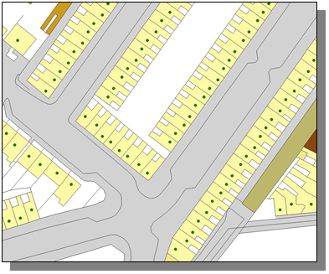

Pointer Data Structure:
Pointer Field Name | Responsible Party
Organisation_Name | Royal Mail
Sub_Building_Name | Local Council
Building_Name | Local Council
Building_Number | Local Council
Primary_Thorfare | Local Council
Alt_Thorfare_Name1 | Local Council
Secondary_Thorfare | Local Council
Locality | Local Council
Townland | LPS
Town | Local Council
County | LPS
Postcode | Royal Mail
BLPU | LPS
Unique_Building_ID | LPS
UPRN | LPS
USRN | LPS
Local_Council | LPS
X_COR | LPS
Y_COR | LPS
Temp_Coords | LPS / Local Council
Building_Status | LPS / Local Council
Address_Status | LPS / Local Council
Classification | LPS
Creation_Date | LPS / Local Council
Commencement_Date | Local Council
Archived_Date | LPS
Action | LPS
UDPRN | Royal Mail
Post town | Royal Mail
Lp_fusionid | LPS
Bu_buildingid | LPS

Product Enquires and Feedback
mapping.helpdesk@finance-ni.gov.uk

